User Manual

5e Character Forge Application

Contents

I. Overview 3

II. Getting Started 3

III. Character Creation 7

IV. Character Maintenance 14

V. Maintaining Settings 33

# Overview

In Dungeons and Dragons, or D and D for short, players use character sheets to track their important information regarding their in game character (such as name, level, stats, and skills). Unfortunately, these character sheets are primarily in print, and those few online compatible character sheets are subpar at best. This makes it more tedious and time-consuming, since players are required to monitor their characters in a manual style, as they need to perform actions such as leveling up, monitoring currency, and rolling dice. In order to combat this problem, the 5e Character Forge application was created. This application places emphasis on being able to monitor created characters in an efficient manner. In addition, 5e Character Forge allows for the storing and managing of multiple characters, making it easier to keep track of characters if one is playing multiple games without having to keep track of physical pieces of paper. This application is supplemental to the D and D 5th edition player’s handbook, created by Wizards of the Coast. As such, the application serves to replace only the character sheet used to track character progression, not the book itself. The following documentation describes how to use the application, which includes, but is not limited to, launching the application, creating characters, and frequently asked questions.

# Getting Started

1. Launching the Application

Locate the 5e Character Forge.exe file in the DnD folder and double-click it to display the application launcher.

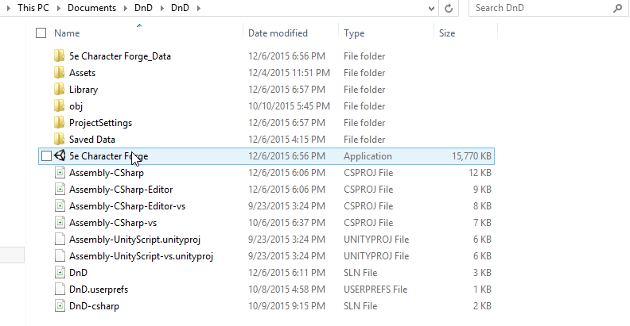

Choose the settings to run the application in and press the *Play!*  Button.

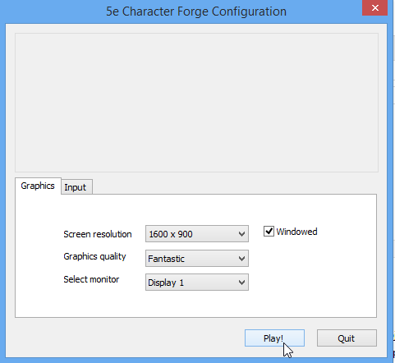

1. Launch Screen

When beginning the 5e Character Forge application, a splash screen will be displayed:



Pressing any key will bring up the next screen, which is the start screen.

1. Start Menu

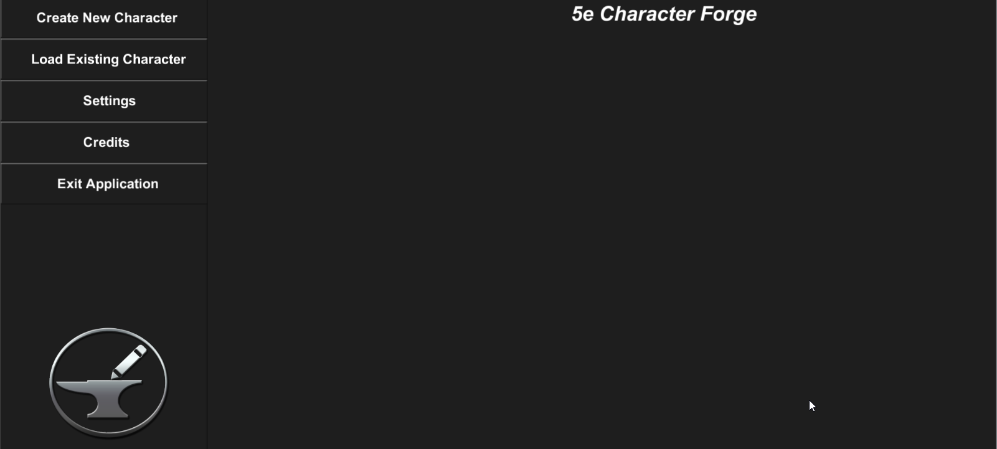

The following options are presented in the start menu:

* Create New Character – begin the creation process for a new character
* Load Existing Character – load all saved existing characters so the user may select which one to load
* Settings – screen in which universal settings can be maintained, such as background music volume and whether the application mode is online or offline
* Credits – acknowledgements in regard to who worked on the application and crediting others for the use of their resources
* Exit Application – enables user to end the application

1. Credits

Select the credits button in the start menu in order to view the credits for the application (see below).

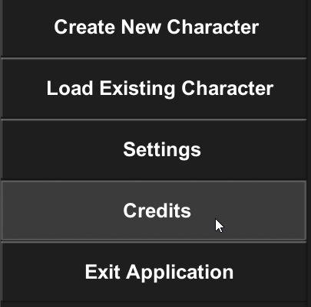

The credits can be exited manually to return to the start screen. Otherwise the start screen will be brought back up after the credits have finished rolling.

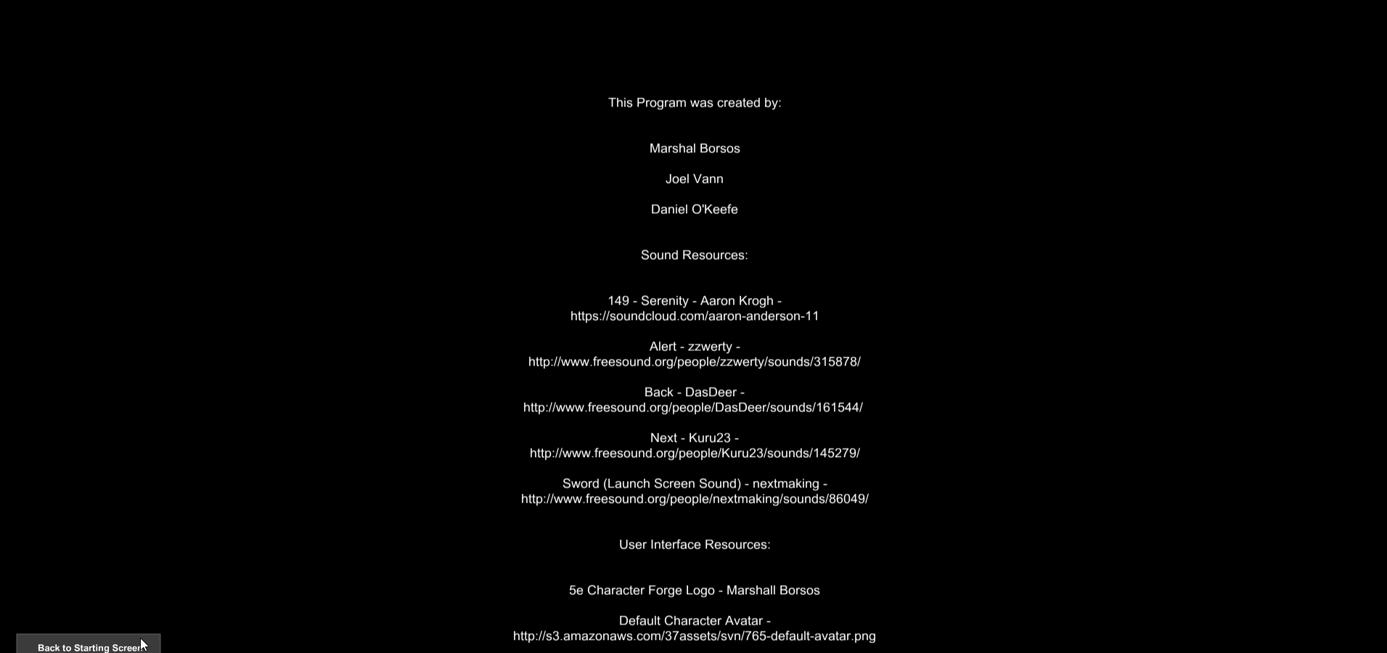

1. Exit Application

In order to exit the application, select the *Exit Application* button and select *Yes* in the popup which appears to confirm the ending of the application.

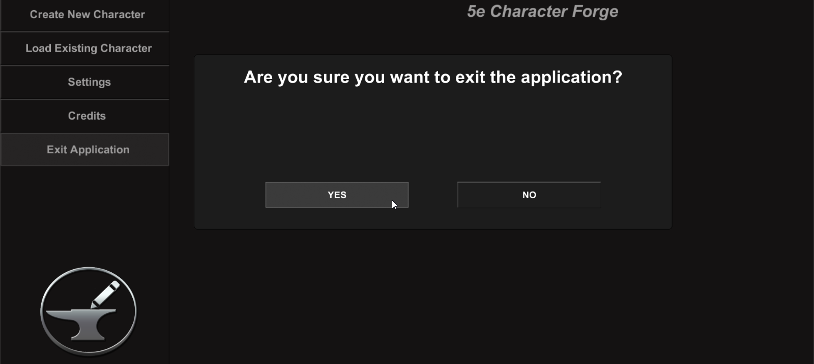

# Character Creation

After selecting the *Create New Character* button in the start or pause menu, the application will open a new set of screens for character creation.

1. Uploading an Avatar

Clicking on the avatar image (see below) displays a popup that allows uploading of an avatar image.

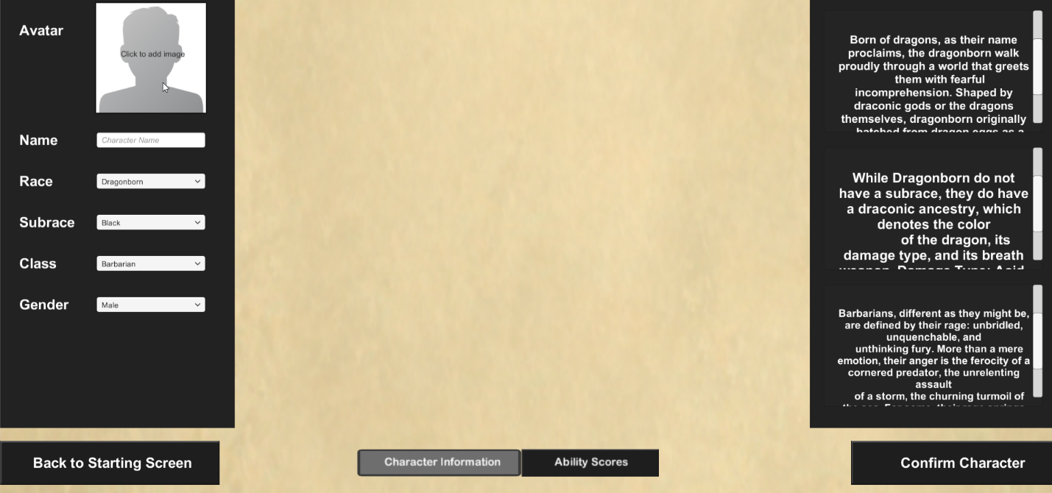

Upload options in the popup include uploading an avatar image from a URL or from a file on the local device.

* Via URL – enter the URL of the image and select the Upload button next to the URL field
* Via File – click the Browse button to search for the image to upload, select the image, then select the Upload button to the right of the Browse button

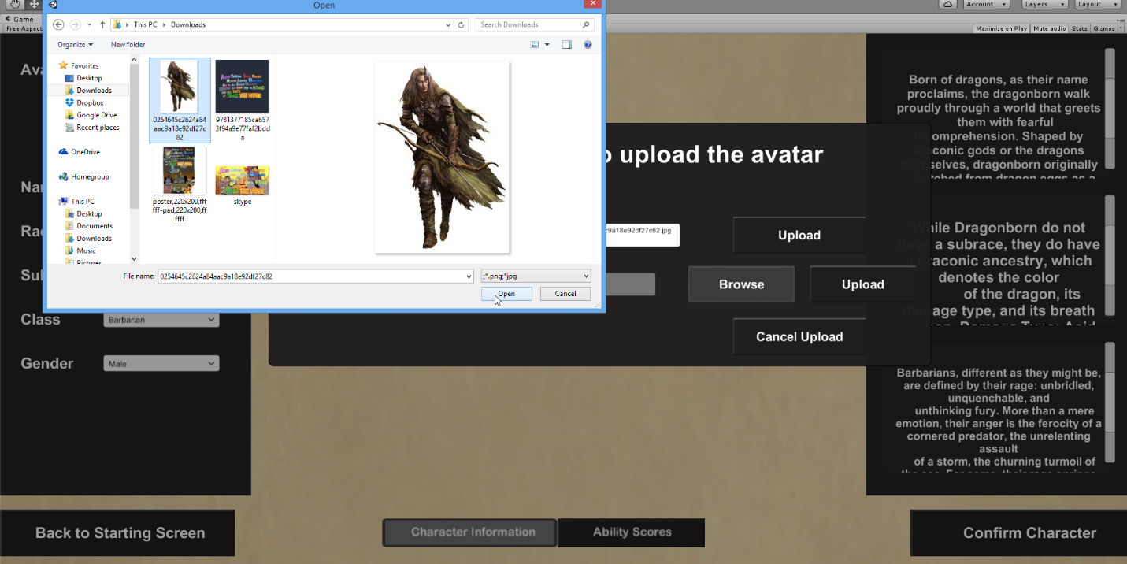Alternatively, the uploading process can be cancelled by selecting the *Cancel Upload* button.

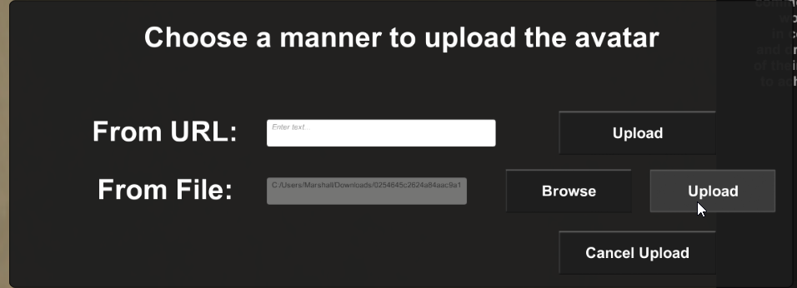

Once this is done, the selected image will be imported as the avatar for the character.



1. Enter Character Name

Enter a name for the character.

1. Select Race and Subrace

Select a race for the character. This selection will affect the character’s ability scores, proficiencies, and languages.

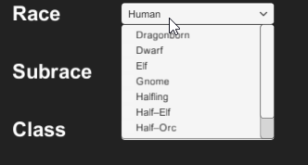

If the selected race has a subrace, then select a subrace for the character as well.

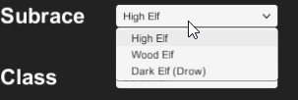

1. Select a Starting Class

Select a starting class for the new character. The character’s class will affect the spells they can learn, health, proficiencies, etc.

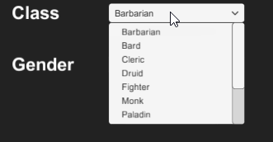

1. Select a Gender

Select a gender for the class (Male, Female, or Other).



1. Enter Ability Scores­­­­­­­­­

The next main part of the character creation process is to enter the starting ability scores of the character, which represent different stats (such as strength, wisdom, charisma, etc.).

There are two ways to maintain ability scores:

1. 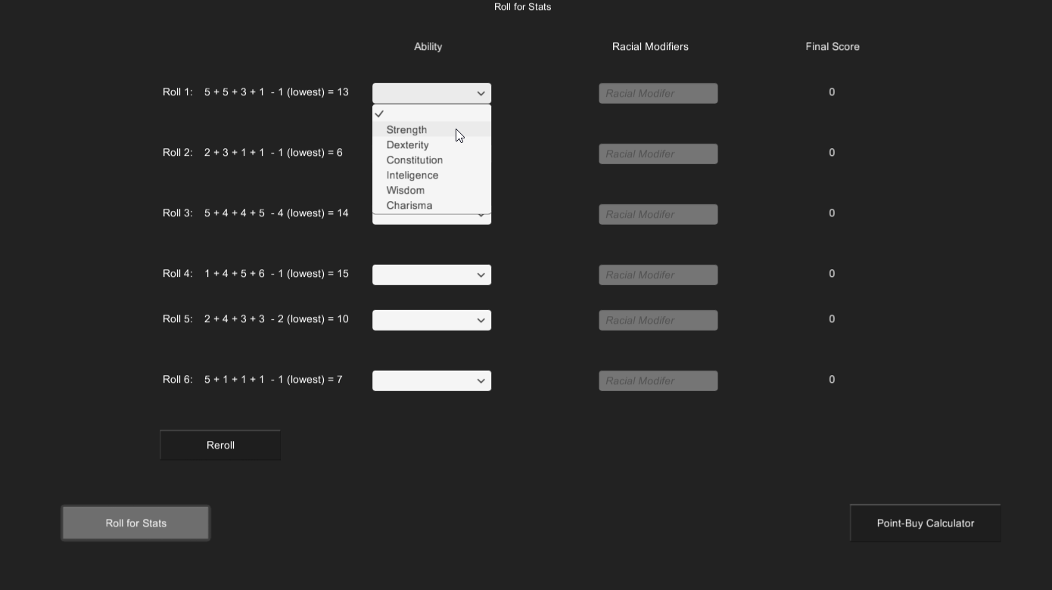Roll for Stats

The *Roll for Stats* method of assigning ability scores acts as the name suggests, in that the *Reroll* button can be used to perform dice rolls, and the results of the rolls can then be assigned to a particular stat. Each roll can be assigned to one statistic.

To assign an ability to a corresponding roll, select the desired dropdown (depicted above) and select the ability to be used for that certain score.

Note: Each ability can only be assigned once, and all abilities must be used.

Note: If an ability is selected, but it is already in use, the dropdown which already contained the ability will be reset.

1. Point-Buy Calculator  
     
   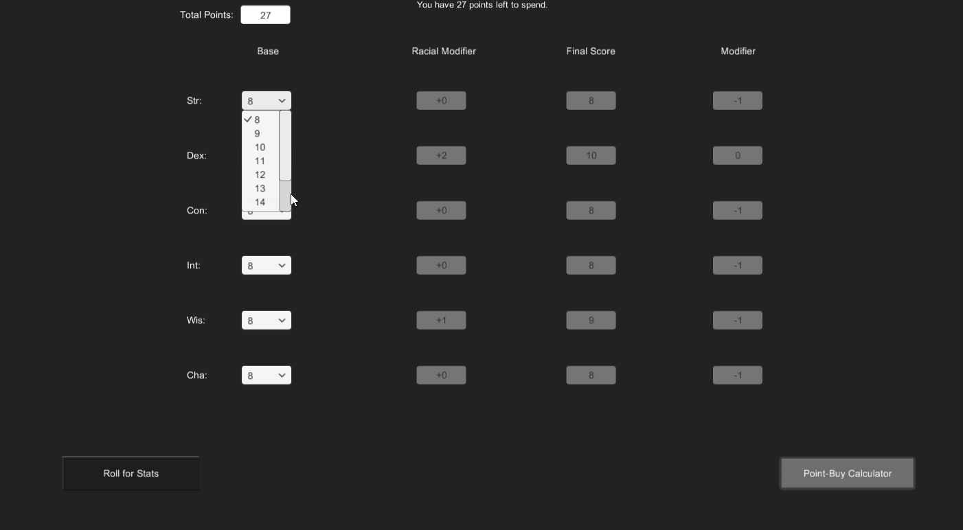

The Point-Buy Calculator allows for a more in-depth way for allocating ability scores. With this mode, 27 points are given to enhance ability scores, and each ability starts with a base of 8 points. Points can be spent to increase the score of a particular ability, and this can be done until the limit of 27 points is reached.

In order to allocate points, select the dropdown which corresponds to the ability whose score should be increased and select the desired value for the ability. These values can be adjusted in any order, and so long as the user has a number of remaining points greater than or equal to zero, he or she will be able to confirm the character when the *Confirm Character* button is selected.

Note that for both ways to edit ability scores, there is a racial modifier. This portion is based on the selected race and subrace which were maintained in the Character Information section.

Note: The ability scores which will be saved with the character are those which are in the last method used to calculate ability scores (i.e., if the application is in the “Roll for Stats” mode, then the ability scores in the “Roll for Stats” mode will be saved, regardless of whether there was data entered in the “Point-Buy Calculator” mode.

1. Confirm Character

To confirm the character creation process, select the *Confirm Character* button and select *Yes* in the popup which displays to confirm the character.

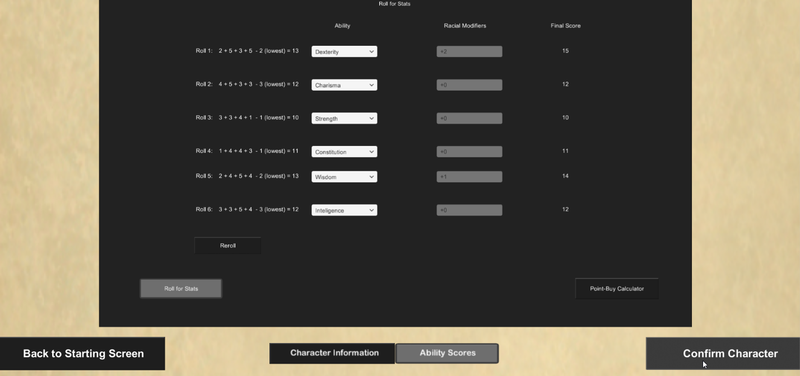

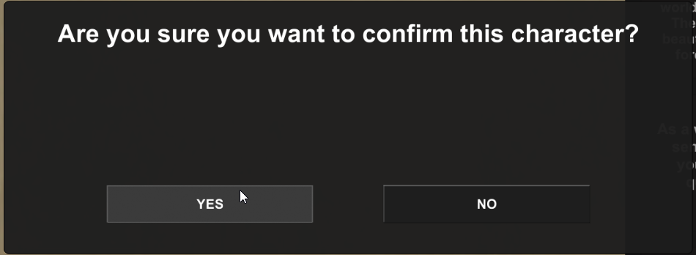

Note: In addition to the prerequisites set by the ability scores, a name must be entered for the character in order to confirm character creation and save the character.

Once the user selects *Yes*, the character will be saved, and the user will be redirected to a new set of screens which will be used for maintaining the character from this point on.

# Character Maintenance

Maintenance of the character after the character creation phase is performed within the below “hub” of screens, which allows for the viewing and editing of the following information:

* Character Overview – character information (such as class, name, race, height, age, alignment, etc.)
* Spells – screen allowing the viewing of known spells and viewing and adding of unknown spells (according to restrictions imposed by the Dungeons & Dragons 5th Edition format
* Proficiencies – screen allowing the viewing, adding, and removing of character proficiencies, which are bonuses to certain aspects of the character (such as lockpicking)
* Combat – allows viewing and editing of combat-related information (such as will, armor class (AC), base attack bonus, etc.), as well as equipped weapons, armor, and attuned items from the character’s inventory
* Feats – screen allowing for maintenance of character feats, which are special talents that differentiate the character from others
* Notes – allows for adding notes about the character’s background, or information relating to the session the character is being used in
* Inventory – screen which allows for viewing and maintaining both coinage (the amount of money the character has on his or her person), as well as the maintenance of the weapons, armor, potions, vehicles, and other categories of items which comprise the inventory of the character
* Dice roller – screen that simulates dice rolls by entering the sides on the dice and the number of dice being rolled

Each of these options corresponds with a header button, which can be selected to go to the corresponding “screen”.

1. 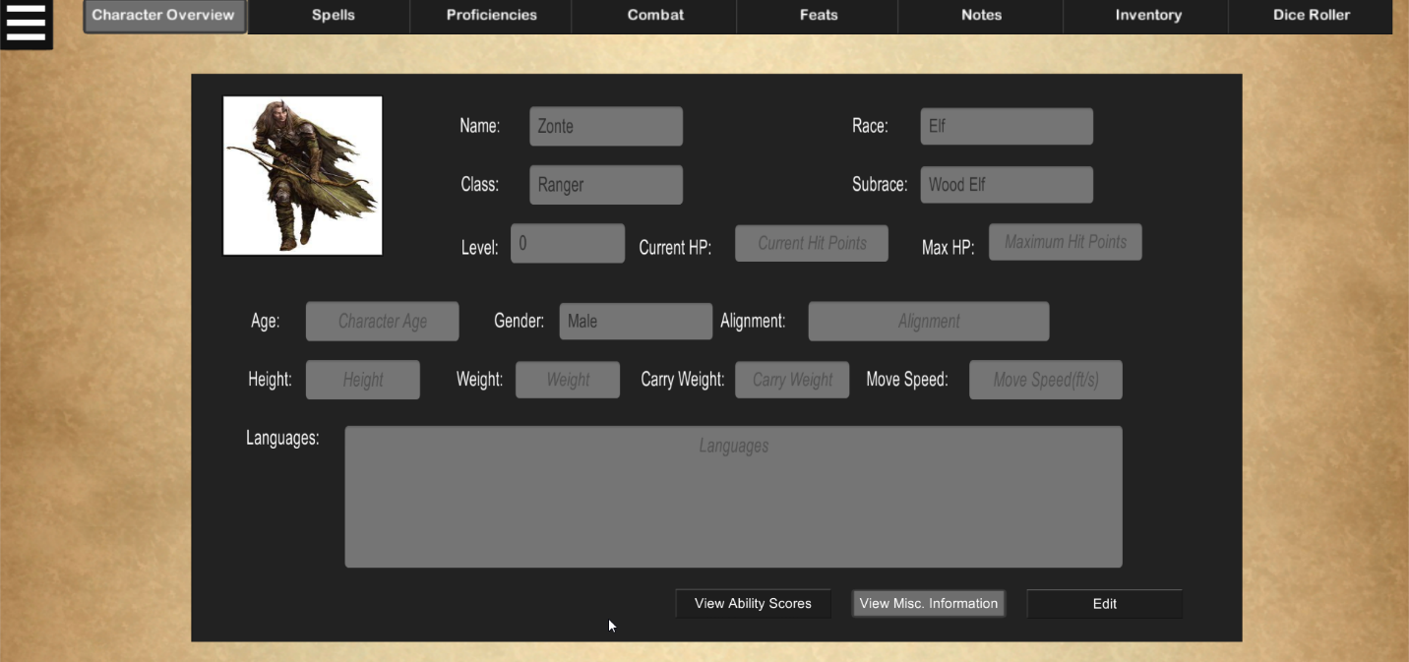Character Overview
2. Viewing / Maintaining Information

The Character Overview section allows for the view of a character’s basic information and ability scores. Such information includes, but is not limited to, the character’s name, race, class, current level, current and maximum health, age, height, carry weight, and languages known. By default, this screen will begin in display mode and will be viewing miscellaneous information (such as age, gender, and weight). The user can view ability scores instead of the miscellaneous information by selecting the *View Ability Scores* button, and can switch back by selecting the *View Misc. Information* button.

Select the *Edit* button to enter edit mode in order to update information about the character.

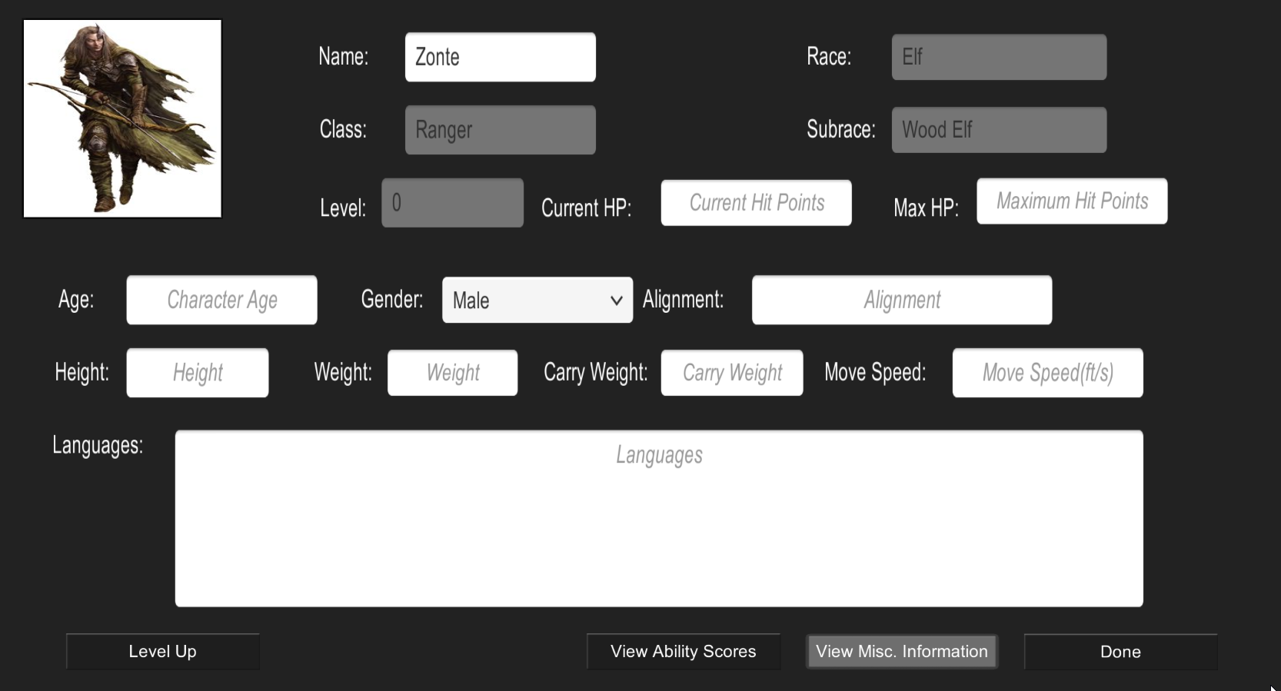

From here, all non-grayed fields, as well as the character avatar, are maintainable. Selecting the *Done* button will save the entered data in these fields. Doing this ensures that when the character is saved that the changes done are saved.

1. Leveling Up

In order to level up the character, enter edit mode and select the *Level Up* button. Doing so will open a new series of screens in which leveling up of the character is done (such as maximum health increases, new feats or class features, and increasing ability scores).

1. Increasing Maximum Health

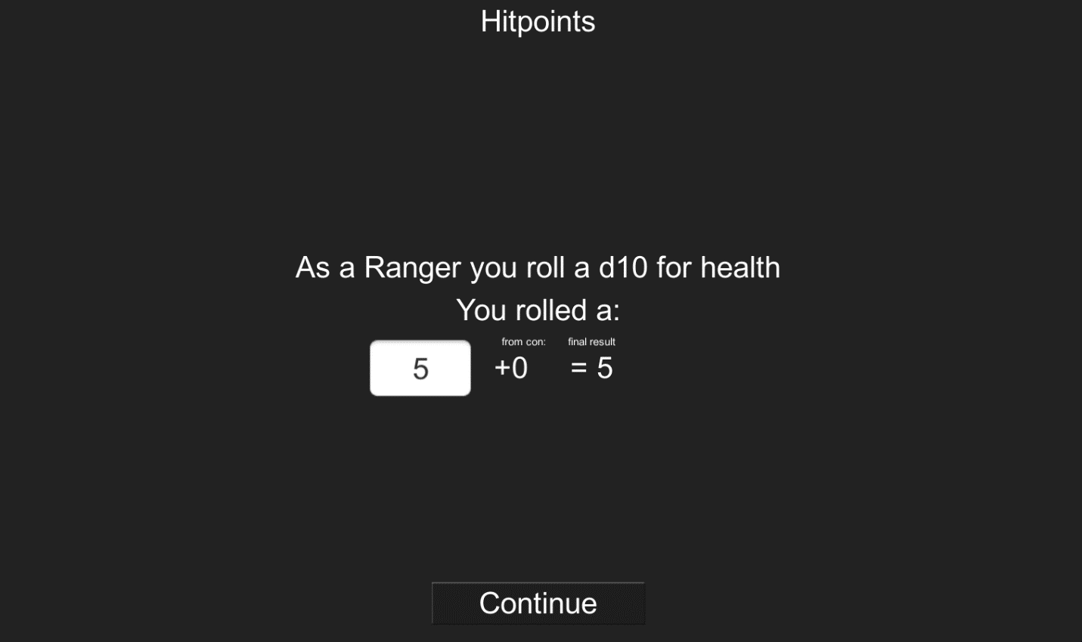

The first screen when leveling up will show a new bonus to the character’s maximum health. By default, the application will perform a dice roll automatically for the health bonus, but it is possible to enter a value for the bonus as well. This bonus is also affected by the character’s constitution modifiers.

Pushing the *Continue* button will continue the leveling up process.

1. Choosing Class Features

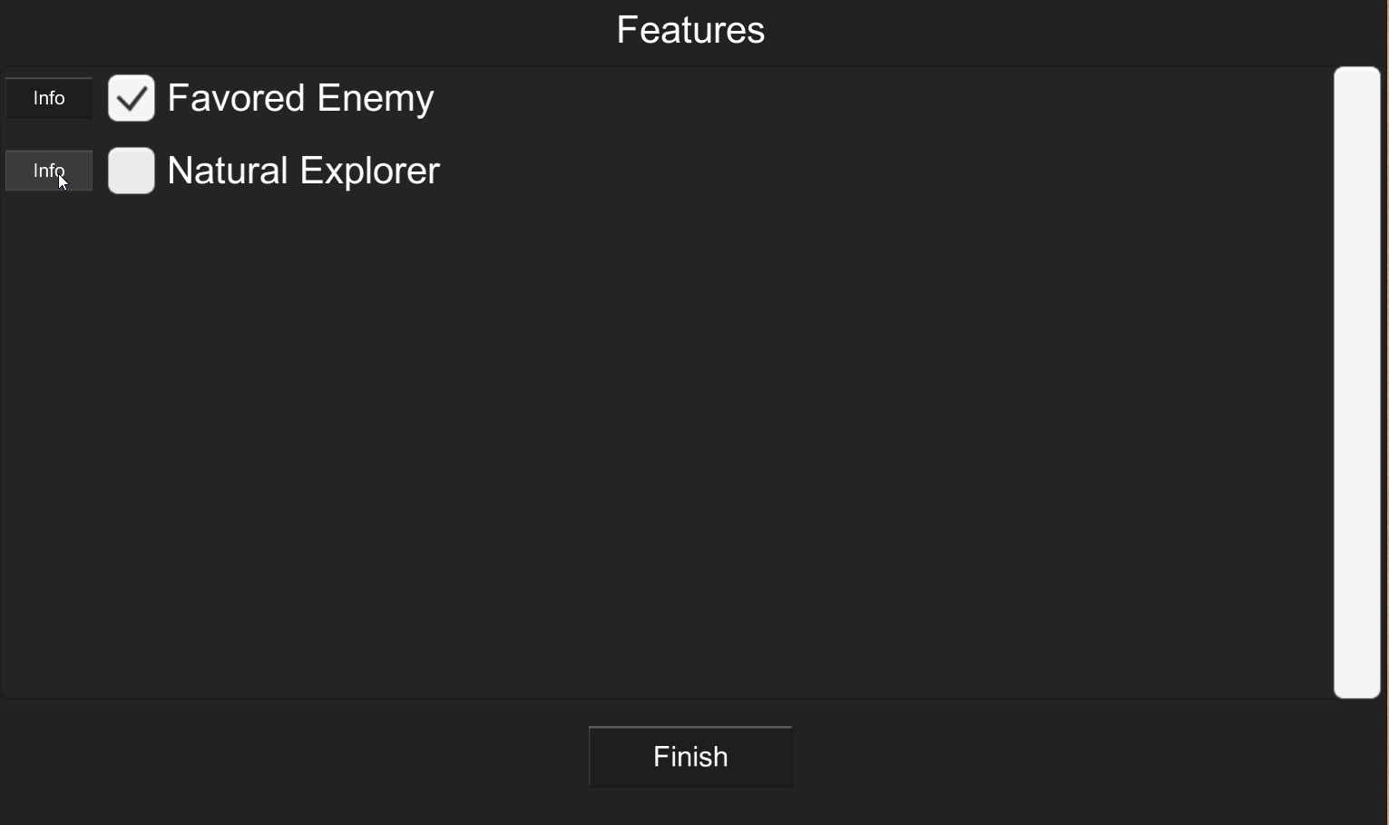

At certain levels, characters gain new features according to their class. This is typically the last screen the user sees in the level up process, and the character’s new class features in a list format. An *Info* button is available for each feature, which, when selected, will display information about the feature.

By default, any class features which correspond to the character’s level will be added to the character. However, a checkbox is available for each feature for if an undesired feature is selected. Unchecking the checkbox which corresponds to the unwanted feature will ensure that the feature is not learned by the character. After leveling up is complete, these features will show in the Feats section of the character maintenance screen, within the Class Feats sub-section.

Once all desired class features have been selected, select the *Finish* button to return to the character maintenance section.

1. Special Cases at Certain Levels

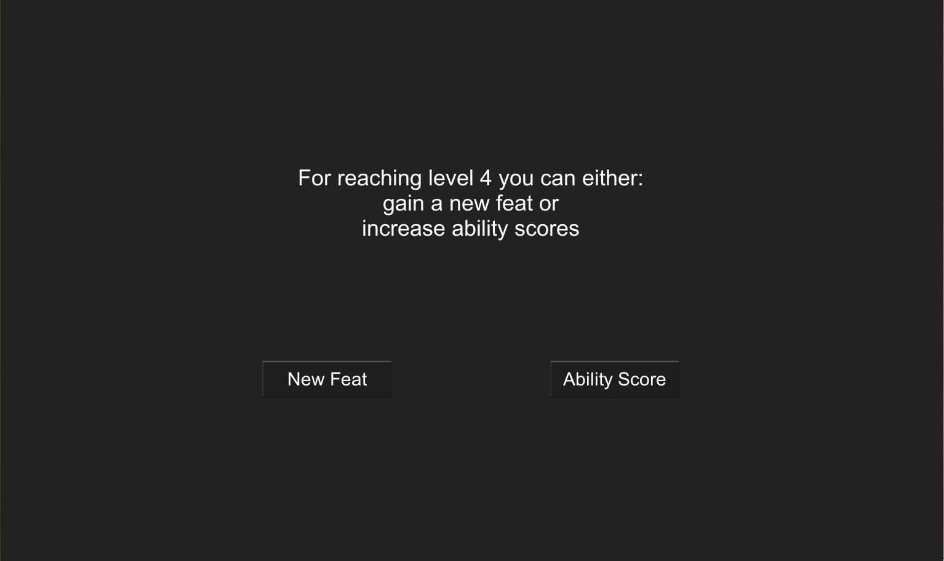

At specific levels, a character can either add a feat or increase two ability scores. Choosing one of these prevents backtracking and choosing the other, so it is heavily advised to pay attention during this level up step. In order to choose a new feat, select the *New Feat* button; otherwise, select the *Ability Score* button to increase the character’s ability score(s).

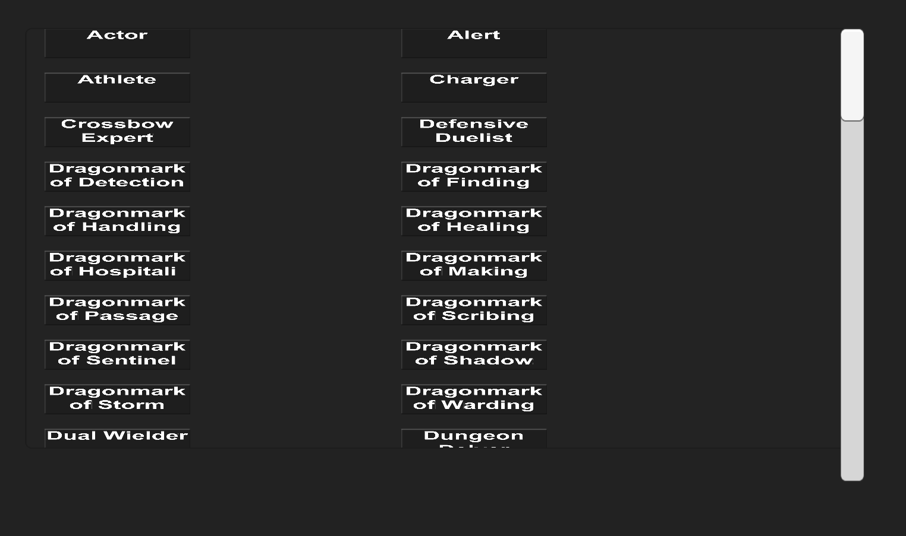

When *New Feat* is selected, a list of available feats to choose from will be displayed. Selecting a feat will bring up a popup containing information on the feat, as well as two buttons. The first button, *Keep*, will add the chosen feat to the Feats section in the character maintenance screen, underneath the Chosen Feats sub-section. Otherwise, the second button, *Cancel*, is available to cancel out of selecting that feat so other feats may be viewed.

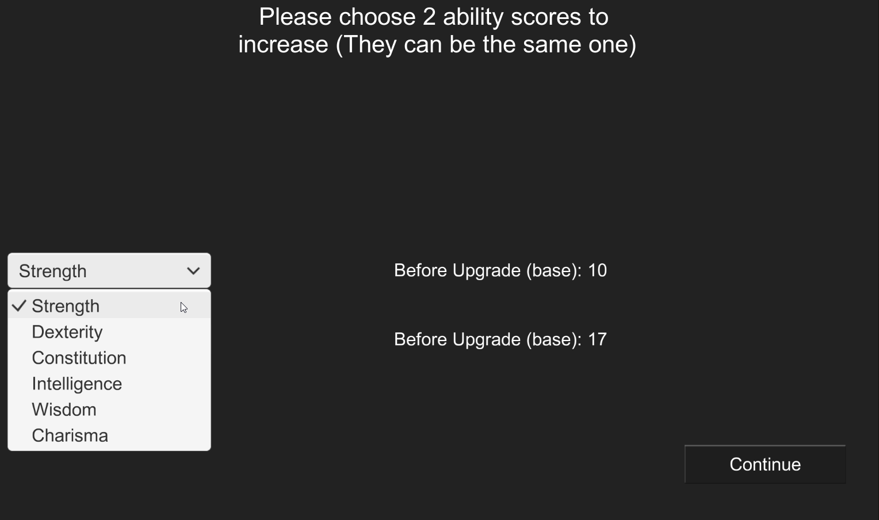

Alternatively, the option exists to increase two ability scores by one point, or one ability score by two points. To do this, use the two available dropdowns to choose the ability score(s) to increase and select the *Continue* button to continue with the level up process.

1. Spells

The Spells section allows shows both the spells currently known by the character and all spells which are not known by the character. Spells can be added, but not removed, as there is no way for characters in Dungeons & Dragons 5th Edition to unlearn a spell.

1. Known Spells

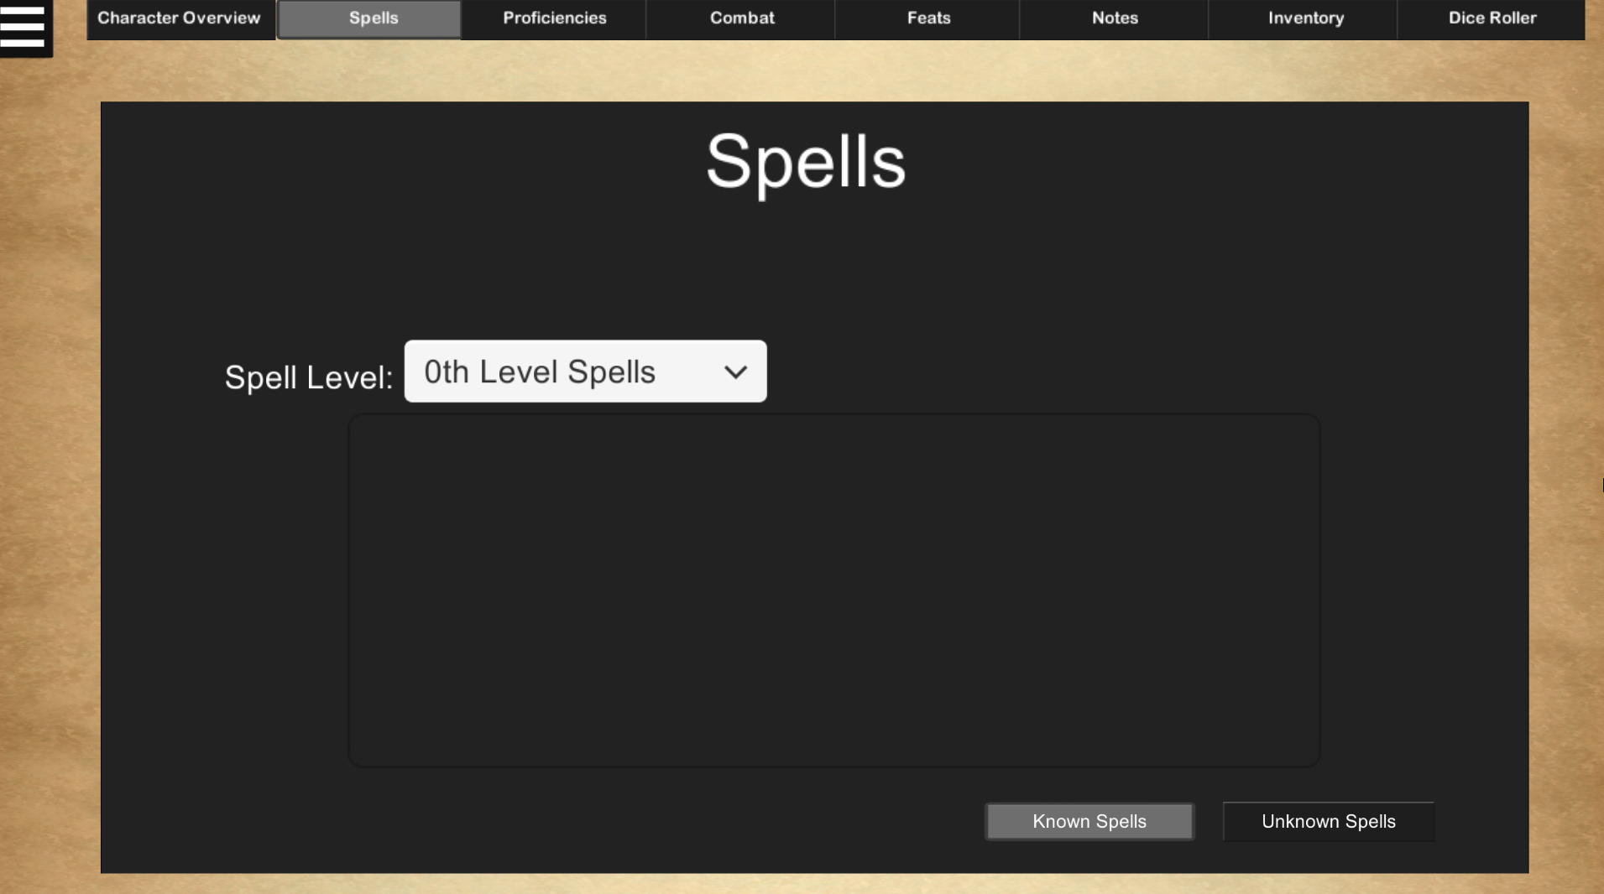

By default, the Known Spells section of this screen will be displayed. Spells are categorized by their level (0 to 9) which can be used by the character’s class (so only spells which can be used by the class of the character will be displayed).

If a spell is selected while in this screen, the information about the spell will be shown. To go back to the list of spells, select the *Cancel* button.

If in the Unknown spells section, return to this section by selecting the *Known Spells* button.

1. Unknown Spells

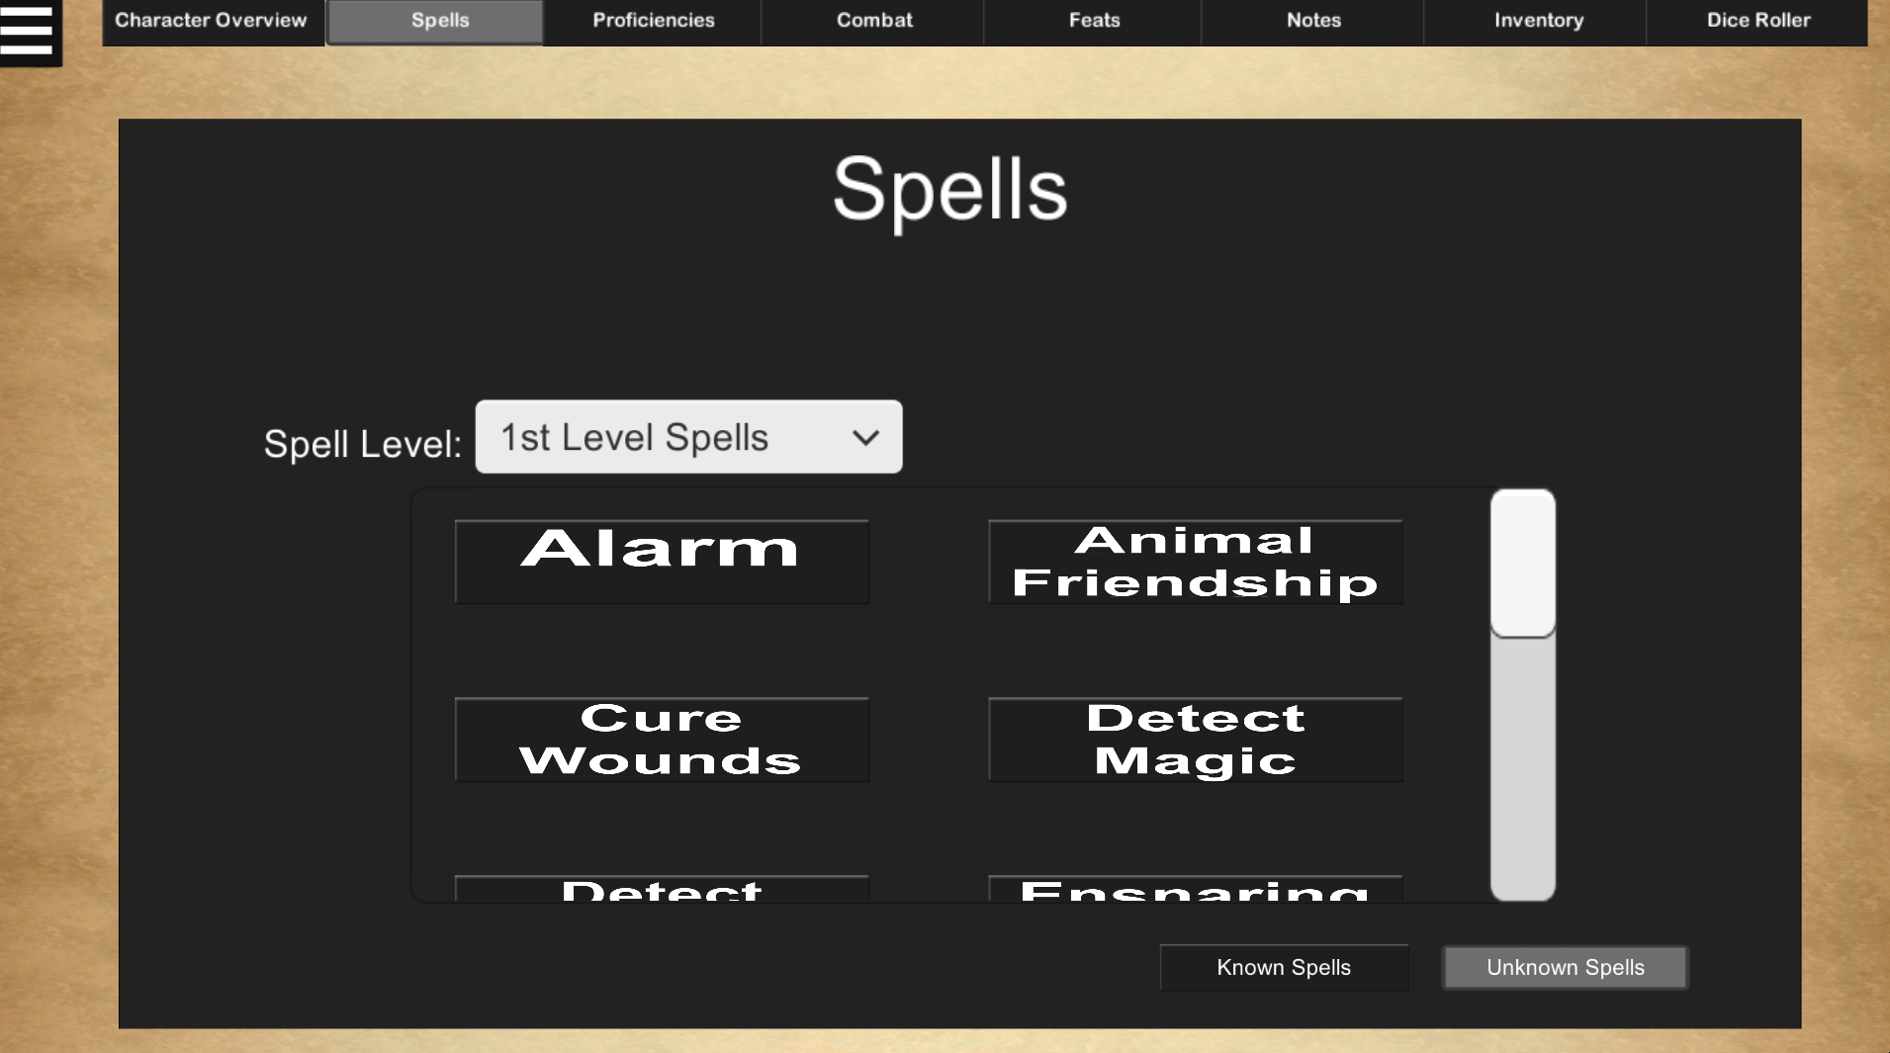

Display this section of the Spells screen by selecting the *Unknown Spells* button.

While in the Unknown Spells section, the app will display spells that the current character does not know. Similar to Known Spells, in Unknown Spells, selecting a spell will bring up its information. Additionally, if certain criteria is met (such as being at a certain level or having an open slot for the spell), selecting the *Add Spell* button will add the spell to the character’s spellbook. As previously mentioned, once a spell is added, it cannot be removed. This spell is only saved to the character when *Save Character* is selected in the pause menu, so be wise when learning new spells. Once the spell is added, it will show in the user’s list of known spells and will be removed from the list of unknown spells.

1. Proficiencies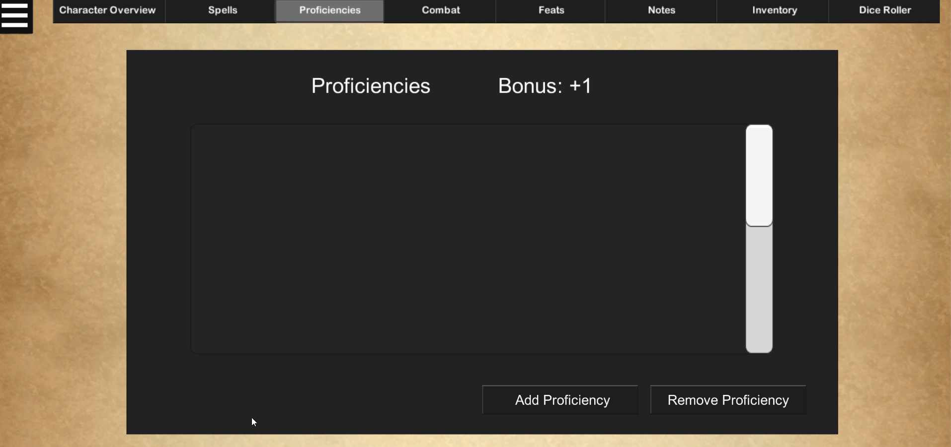

The Proficiencies section allows for viewing of the current character’s bonuses, which can be added or removed.

In order to add a proficiency, select the *Add Proficiency* button to display a popup. Within this popup, enter the name of the proficiency to add and select the *Continue* button to complete the adding process. Alternatively, selecting the *Cancel* button will cancel the process.

Note that it is required to enter a name for the proficiency, and that two proficiencies cannot have the same name.

In order to remove a proficiency, select the *Remove Proficiency* button to display a popup. Within this popup, enter the name of the proficiency to delete and select the *Continue* button to complete the deletion process. Alternatively, selecting the *Cancel* button will cancel the delete process.

1. Combat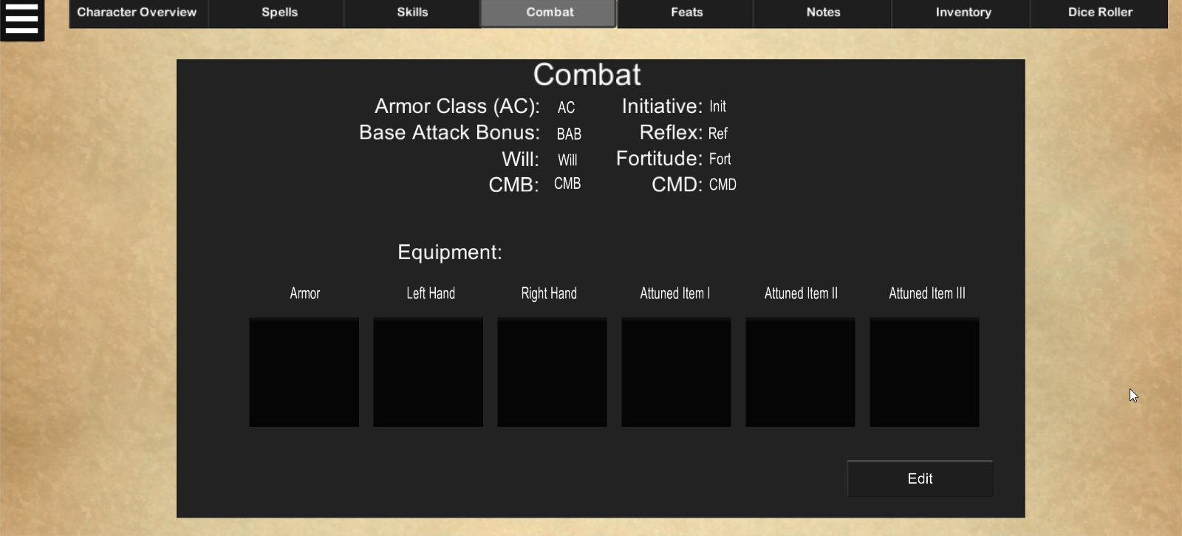

The combat section is used for maintaining information related to the character’s equipment and combat information. The top section contains information relating to combat, such as base attack bonus and armor class, while the bottom portion contains the character’s currently equipped items. To maintain information in this screen, select the *Edit* button in the bottom-right corner.

1. Maintaining Combat

Maintaining combat information is similar to how the character overview information is maintained. Therefore, update the desired fields and select the *Done* button in the bottom-right corner to confirm changes made.

1. Maintaining Equipment

While in edit mode, select the square button which corresponds to the type of item to be equipped. Doing this when no item is equipped in that spot will open a popup which will allow the user to view items within the character’s inventory so he or she can determine which item to equip. While in this popup, the category of items which display can be changed by using the provided Item Category dropdown. When an item is selected, the information about the item will be displayed. Selecting the *Cancel* button will end the process and selecting the *Equip Item* button will add the item to the selected equipment slot.

To remove an item, select an equipment slot with an item assigned to it, and select the *Unequip Item* button. This allows equipping of a different item in that slot.

While in display mode, information about the item can be viewed by selecting the equipment slot of the desired item.

Note that equipped items will not appear in the character’s inventory, and items will need to be unequipped before their information can be changed or before the item can be deleted.

1. Feats

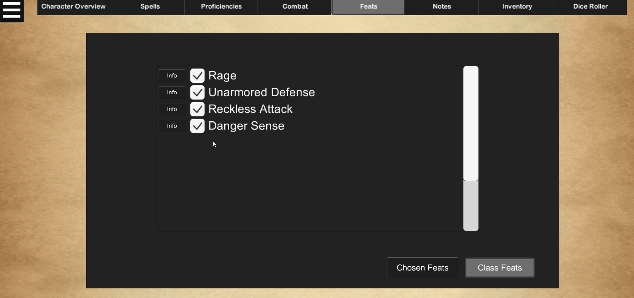

The Feats section can be used to maintain talents specific to the character being used. In this section, it is possible to view either class-specific feats, or feats chosen upon reaching certain levels.

1. Chosen Feats

The Chosen Feats portion of the Feats screen shows the information relating to feats chosen at certain levels when leveling up.

While in this section, it is possible to view the feats in a list format. Each feat has a corresponding *Info* button which can be pressed to display a popup containing information about the feat. This popup can then be closed by selecting the *Return* button.

If viewing class feats, return to the chosen feats by selecting the *Chosen Feats* button in the bottom-right of the screen.

1. Class Feats

The Class Feats portion of the Feats screen shows the information relating to class-specific feats chosen when leveling up.

While in this section, it is possible to view the feats in a list format. Each feat has a corresponding *Info* button which can be pressed to display a popup containing information about the feat. This popup can then be closed by selecting the *Return* button.

If viewing chosen feats, return to the class feats by selecting the *Class Feats* button in the bottom-right of the screen, to the right of the *Chosen Feats* button.

1. Notes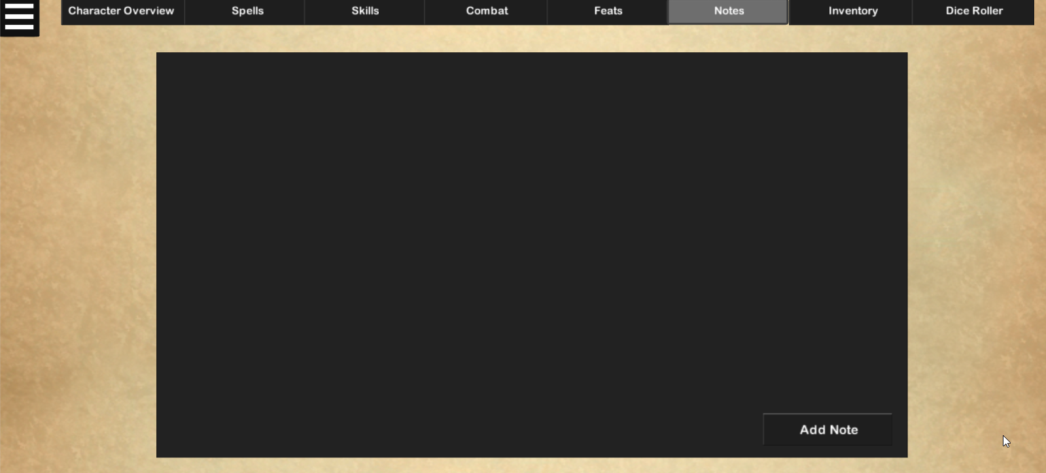

Within the Notes section, users can add entries for their character’s background or to record information about the session the character is involved in.

In order to add a note, select the *Add Note* button. From here, the title, date on which the note relates to, and the subject of the note can be entered. Once these are filled, the *Save* button can be selected to save the note and add it to the list of the character’s notes.

Note that it is required to enter a title for the note.

Once this has been performed, select the note in the list to edit its contents or delete the note from the list.

These notes will be saved along with the rest of the character information.

1. Inventory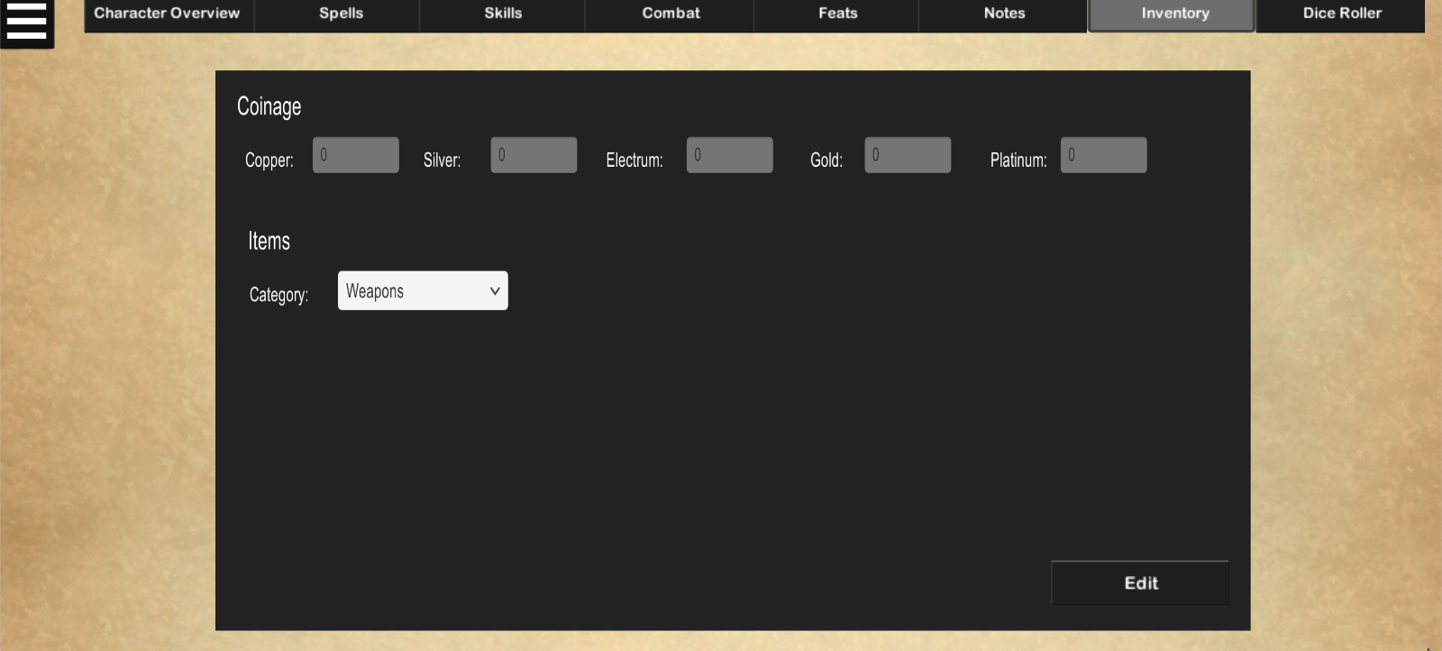

The inventory screen allows the maintaining of the amount of currency and items in the character’s possession. The Coinage section contains fields for each of the five types of currency in Dungeons & Dragons 5th Edition (copper, silver, electrum, gold, and platinum), while the Items section categorizes the character’s inventory into predefined categories. These categories are:

* Weapons
* Armor
* Poisons/Potions/Oils
* Vehicles
* Crafting Materials
* Miscellaneous

To change which item category to display, click the Category dropdown and select the desired category.

1. Maintaining Coinage

Maintaining the Coinage fields is the same as maintaining the character information and the combat information in that the user must enter edit mode, maintain the desired fields, and select the *Done* button to confirm changes.

1. Maintaining Inventory

While in edit mode, selecting the *Add Item* button will allow adding of items. From here generic information about the item can be entered, such as name, description, weight, and cost. More specific information about the item can be maintained as well, and these fields will vary depending on the category selected in the Category dropdown. Once the item information is filled out, save the item by selecting the *Save* button.

Note that it is required to enter a name for the item; all other information about the item is optional.

In order to view the added item, select the item category of the item in the Category dropdown. Clicking the item will show its information – and, if done in edit mode, the item information can be updated or deleted by selecting the *Delete Item* button.

1. Dice Roller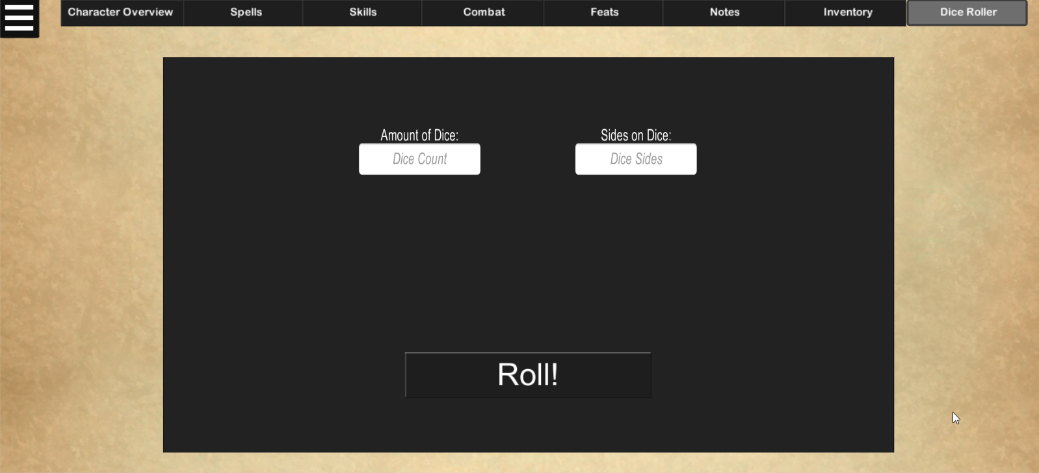

The dice roller screen simulates dice rolls without the need of physical dice. In order to do this, enter the amount of dice to roll and the number of sides each dice has, then select the *Roll!* button to see the results of each roll and their total.

Note that the sides of the dice is the same for each dice being rolled, and that it is not possible to roll dice with a differing amount of sides in the same roll.

1. Additional Functions
2. Using the Pause Menu

The pause menu can be opened by selecting the button in the top-left of the screen.



This screen is formatted similarly to the main menu, but there are some new functions which can be chosen:

* Save Character – saves the changes done to the character (according to the specifications described in the explanation of each screen)
* Delete Character – deletes the current character after the selecting Yes in a confirmation prompt

The other options in the pause menu act the same as they do in the start menu, with a couple of minor changes. If attempting to create a new character or trying to load an existing character, a prompt will appear asking to continue that notifies that all unsaved changes to the character will be lost. 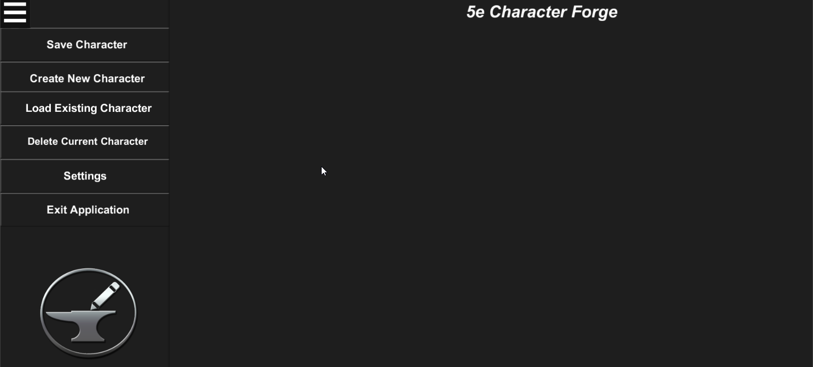

1. Saving the Character

In order to save changes done to the character, select the *Save Character* button. A popup will appear informing that the save was successful

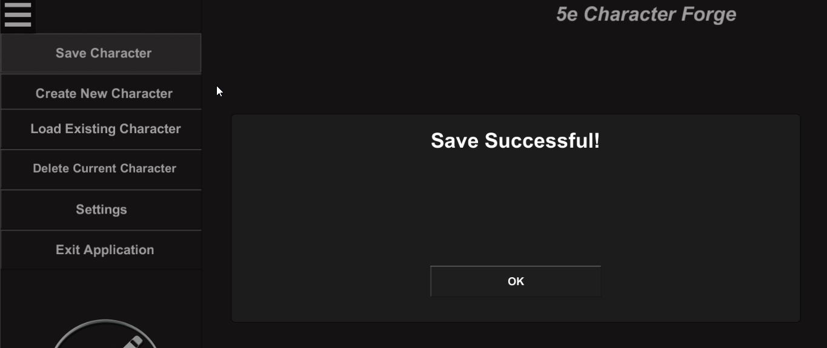

1. Load Existing Character

In order to load a previously saved character, select the *Load Existing Character* button to display a list of the possible characters to load. When a character from this list is selected, the popup will appear notifying of unsaved changes. Selecting *Yes* will continue to load the character.

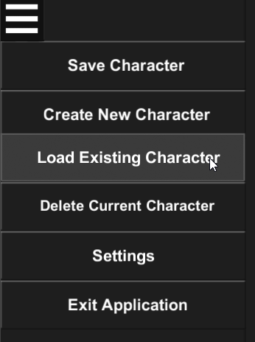

1. Delete Current Character

In order to delete the currently selected character, select the *Delete Current* Character button, which will cause a prompt to display warning that there will be no way to recover the character’s data.

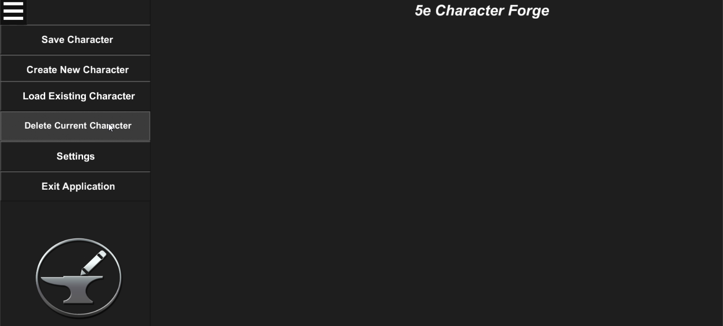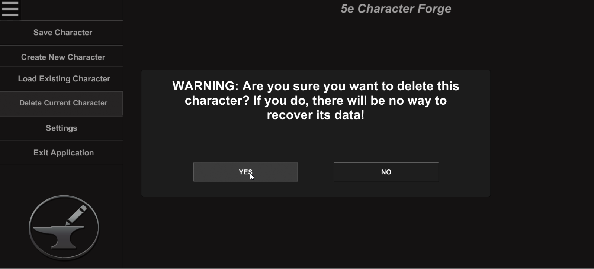

1. Closing the Pause Menu

In order to close the pause menu, select the same button in the top-left corner of the screen which was used to open the pause menu.



# Maintaining Settings

In order to maintain universal settings, select the *Settings* button in either the pause or start menus.

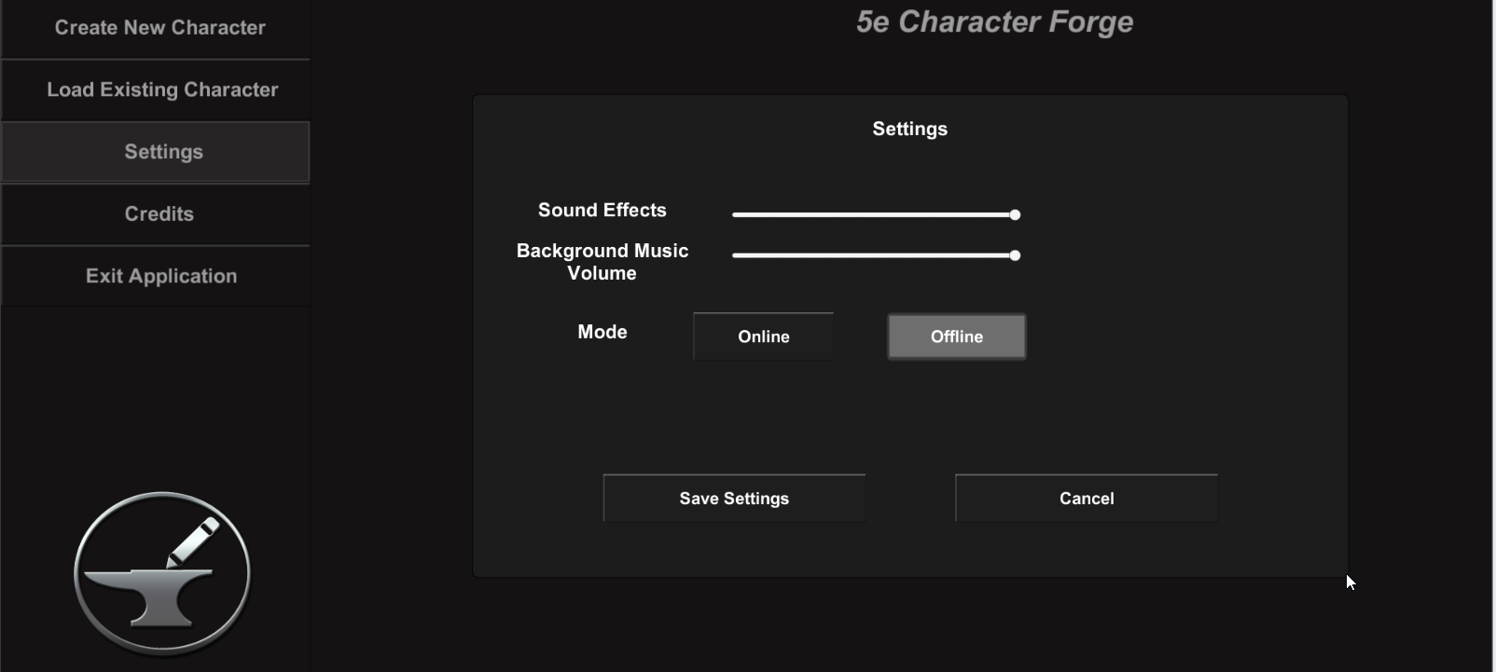  
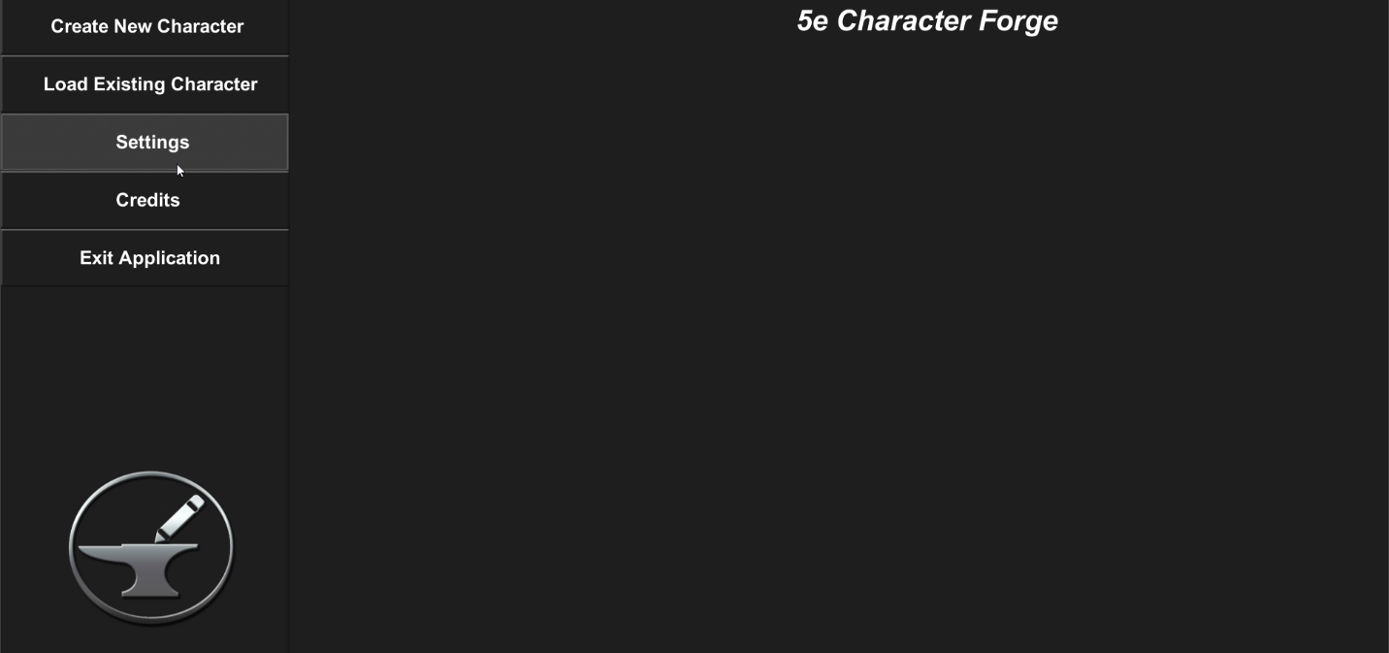From here, it is possible to adjust the application’s volume for the background music, volume for sound effects (such as button clicks and alert notifications), and change the mode to either online or offline.

To adjust the volumes, use the corresponding sliders in the settings menu. Moving the slider left will decrease the volume, while moving the slider to the right increases the volume.

There are two modes for the 5e Character Forge application:

* Online – data retrieved from external resources (such as the class, race, and spell descriptions) will be retrieved from the internet
* Offline – data retrieved from external resources will be retrieved from local files which are stored on the computer (allows for offline use in case the user loses his or her internet connection)

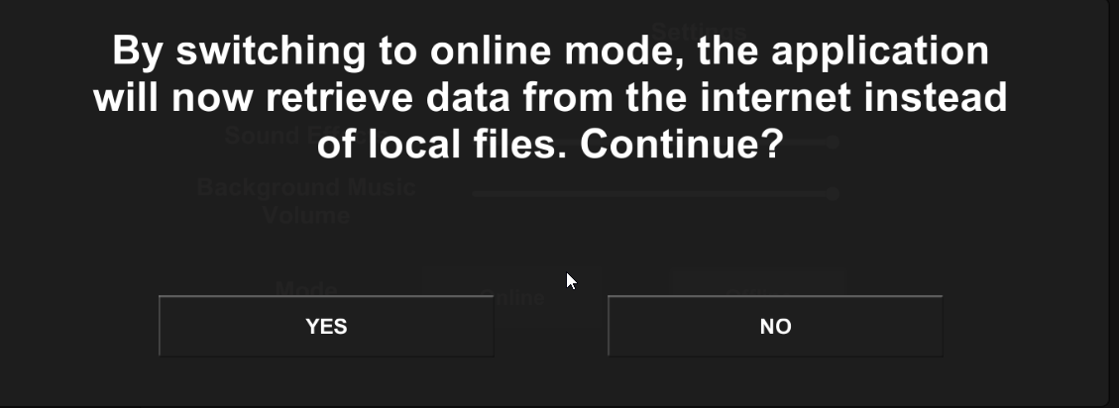When a mode is selected, the following warning of how the change will affect the application will be displayed:

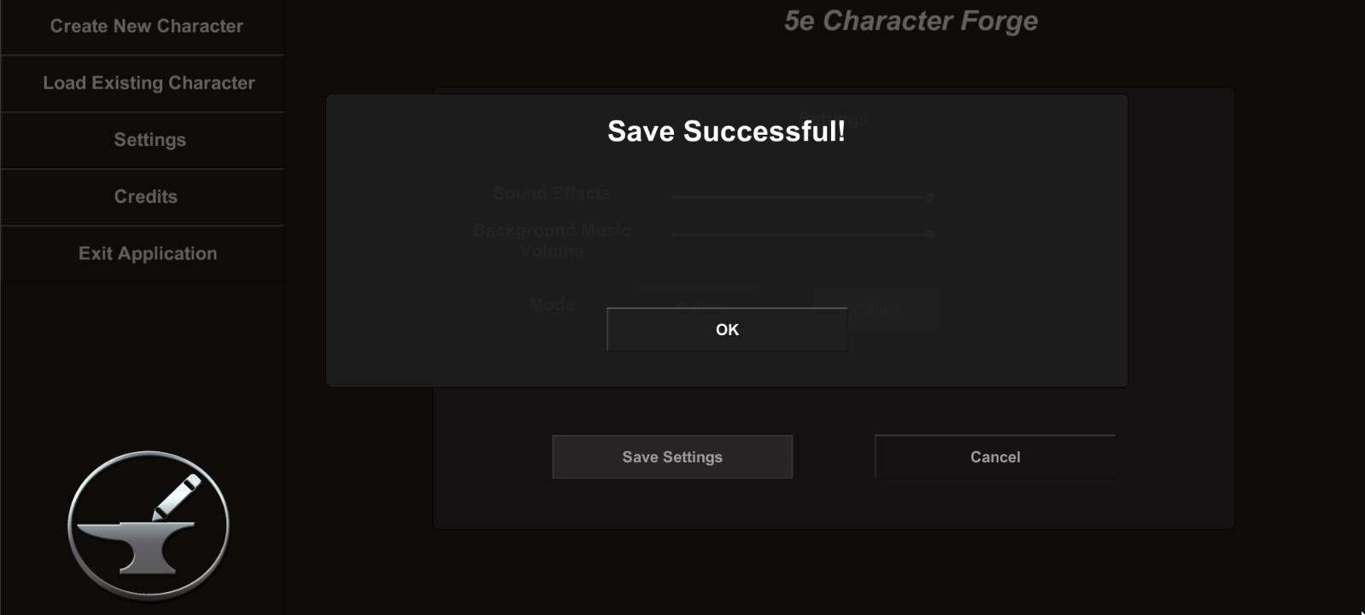Once satisfied with the changes, save said changes by pressing the *Save Settings* button:

Alternatively, cancel changes by selecting the *Cancel* button.